**Andrew Trail Crypto-Currency Tracker**

**Brief**

An application to allow users to store and track their crypto currency holdings. The software will have a GUI. It will allow users to input quantities purchased and save and read to and from an external database. They will have the option to output a pie chart of their holdings to another external file. The application will display a total portfolio value, along with a detailed breakdown.

**Analysis**

**Functional Requirements:**

Initial form requires a database to be selected or created

Edit or add balances for each coin

Total folio price displayed

Folio display currency can be changed (USD/GBP/EUR)

Can open different database file from main form

Can save current folio to new database file

Generate a pie chart of different crypto holdings and output to external file

Displayed with a GUI

Display current value of all currencies included

**Non Functional Requirements:**

Should be saved as a portable .exe file

Code should be modular, with clear comments and meaningful variable names

The program should not use a large amount of processing power, or storage space

Planning to be completed by 2/3/18

Development to be completed by 11/5/18

Presentation to be given between 14/5/18 and 25/5/18

Evaluation due by 1/6/18

**Project Aim:**

The aim of this project is to create a simple, intuitive desktop application to keep track of users crypto currency holdings.

**Top Level Use Case**

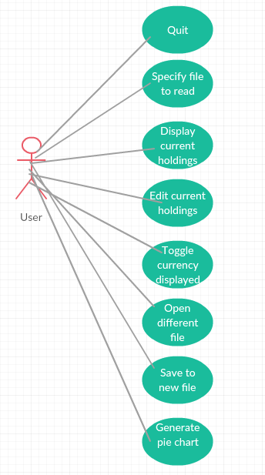

**Background Research**

I have studied a similar application to this, and this helped me to decide what I would

include with my application. The app is called Blockfolio, and it is an Android/iOS app for

mobile phones.

I felt the interface had a clunky, unintuitive design in places, and that I could improve upon it. In addition, I wanted to create a desktop application, rather than a mobile app, for use when I’m at home on my desktop.

The application also does not have the ability to manage multiple user accounts, which I will

be including. Finally, there is no option to display a visual breakdown of the distribution of your crypto holdings.

**Resources**

Python 3 – I have elected to use python as it has readily available packages for many functions, such as the coinmarketcap API, and plotly for generating a pie chart. In addition I am familiar with the language.

Creatly – I will use this as it is a free online environment to generate UML diagrams

Tomsplanner – This is an online environment for creating a Project plan, with detailed times, deadlines. Can also display this information in a Gantt Chart

App.jar – This is a library I will use within Python in order to generate the GUI

Mysql python library – Used to create and edit database files

Json library – used to scrape GBP/USD/EUR price ratios from the net

Axure – Used to generate the wireframes

**Information Sources**

I am familiar with Python; however, will undoubtedly encounter problems I haven’t seen before. To remedy any such problem, I will use primarily stackoverflow.com, and if I can’t find the solution I require I will move to google.

I will also use the plotly webpage which shows lists of commands to generate the chart I require.

Finally, I will use the documentation provided alongside the coinmarketcap API for command lists also.

**Entity Model**

|  |  |
| --- | --- |
| User | |
| Primary Key | Coin |
| Secondary Keys | Price  Holdings  Coin_Holdings_Value |

**Detailed Use Case Diagram**

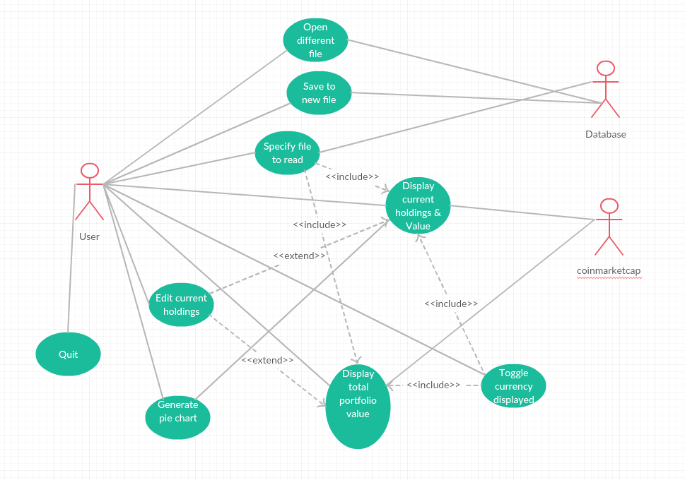

**Activity Diagram**

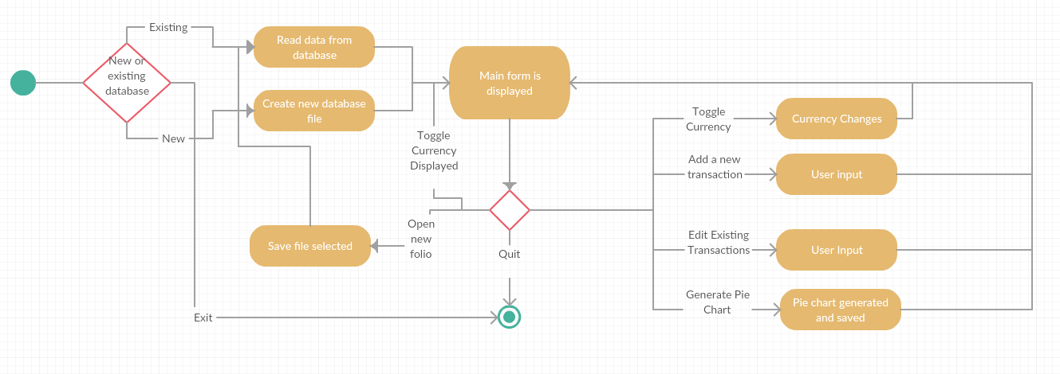

**Interface Design**

**Initial Form**

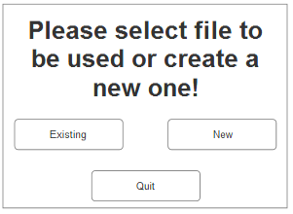

**Main Form**

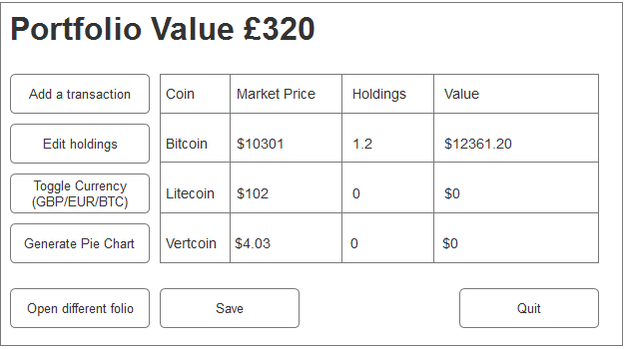

**Add Transaction Form**

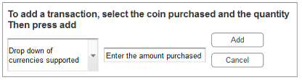

**Edit Transaction Form**

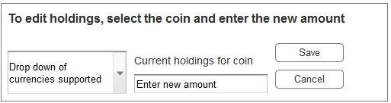

**File selection form**

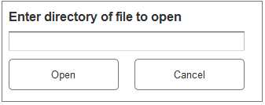

**Save dialog**

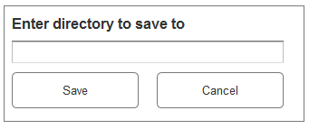

**New file dialog**

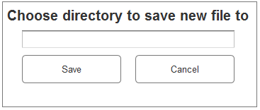

**Project Plan:**

